Return to School Plan ~ Fall 2020
St. Peter’s School
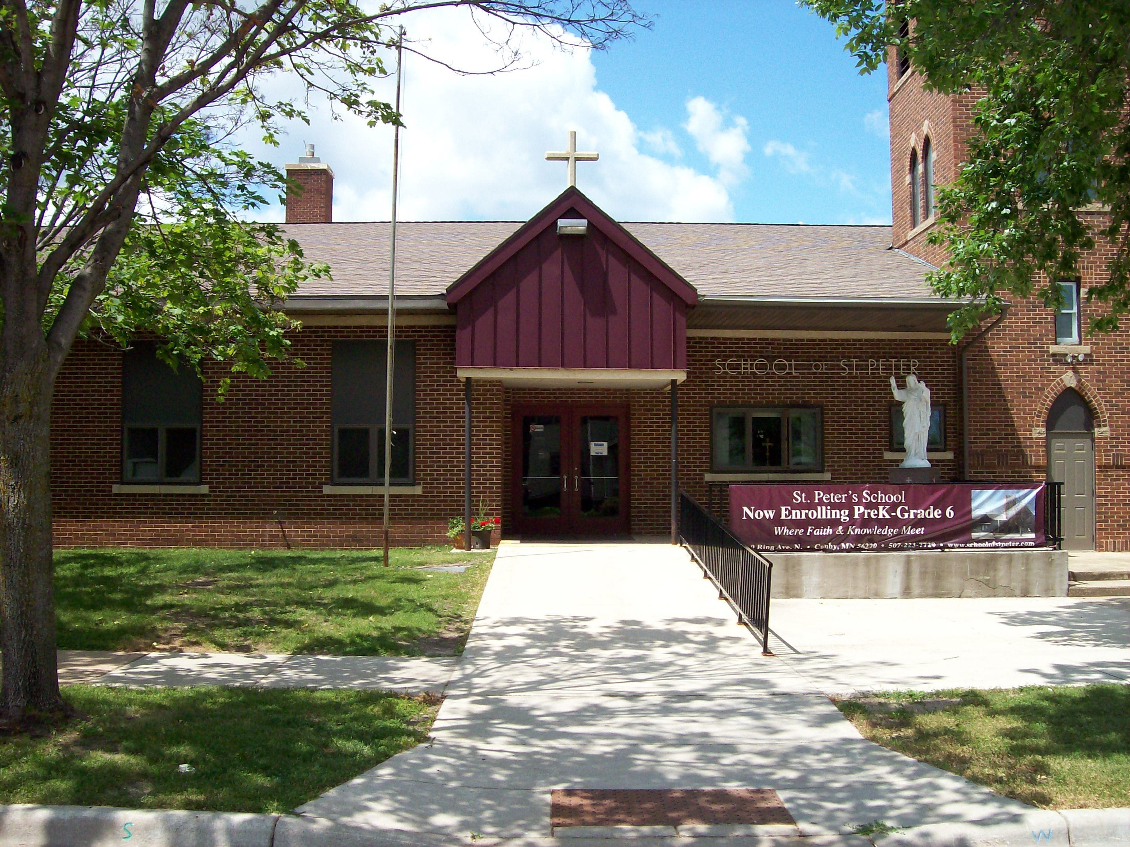

Task Force Members
Natalie Oellien, Sara Abrahamson, Angie Briggs, Lindsey Anderson, Joe Citrowske, Kathy Antony, Kari Goplen & Lori Rangaard

Education Committee
Brian Zitzmann, Wendy Sterzinger, Sam Hentges, Crystal McKeen, Jon Briggs, Jessica Wilson, Casie VanEngen

410 Ring Ave. N.; Canby, MN 56220
www.schoolofstpeter.com |T: 507-223-7729
Disclaimer: The following is a plan to reopen school and mitigate the spread of COVID-19 in our school. This Plan does not guarantee the absence of COVID-19 or other illnesses in our school. With all plans, there will need to be adjustments based on any new guidance from MDE, CDC, Catholic Mutual, Diocese of New Ulm, and/or Countryside Public Health. All families must sign the Return to school waiver included in the fall packet. We are grateful for your continued patience and flexibility as we work to keep our students, staff, visitors, and school community healthy and safe as we prepare for in-person learning. .
The Task Force, Education Committee, Staff and Administration have taken careful consideration on the safety and well-being upon the return to school for students and staff for the 2020-2021 school year. The Return to School Plan was generated with guidance from the Diocese of New Ulm, the Greater Schools of MN Planning Guide, and many other health care and public guidelines listed at the end of the document. The physical and mental health of the students were of the greatest importance when developing plans and procedures. As we know, the recommendations and executive orders are ever-changing in response to COVID-19. All changes made to the return to school plan will be communicated to all parents once it has been officially discussed by the Task Force and administration following any new guidance announcements from local or state health officials.
The Mission of St. Peter’s School will continue to be used daily in order to make sure that…“Catholic teaching and values are integrated into all areas of the curriculum to develop each child’s body, mind, and soul.”
Please continue to read all materials sent home in Monday folders or via email to make sure we are all doing our part to continue to keep our students and staff safe while returning to school in-person.
Sincerely,
Mrs. Rangaard

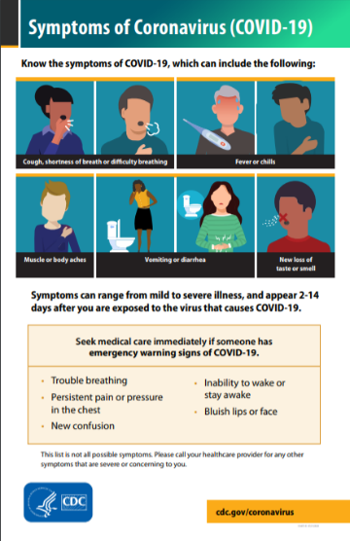
Operational Practices and Procedures
- Designated COVID-19 Point of Contact: Lori Rangaard
- Countryside Public Health Contact: Ashlie Johnson
Adaptability
This plan will be evaluated by the Task Force, Education Committee, and staff via meetings and email communication. Since we are a small school, staff will be able to easily communicate daily to modify minor parts of the plan as needed to keep the students, staff, and visitors safe. Once students and staff are present in the building, we may find there are unforeseen circumstances that would alter our original plan. Any major changes to the plan will be communicated to parents.
• Any changes that should need to be made will be sent out via email or posted on Facebook if an immediate action needs to be taken. The school will also start using the Remind app to get notifications to parents immediately if needed.

Entrance Protocols
Students & Staff will enter through the main front door and immediately get temps checked and recorded by a para or office staff as well as answering basic COVID questions. In the morning, all students in grades K-6 will go directly to the lunchroom to designated grade area. Personal items will be placed on empty chair next to where they sit. Those eating breakfast will then proceed to get their tray. Those not eating breakfast will remain at their table spot until dismissed for class. Preschoolers will go to their classroom upon arrival and get checked in for the day. Those eating breakfast will go downstairs and return to the room when finished eating.
Visitors and parents are not allowed throughout the building at this time. Any visitor who must enter the building during the school day will need to verify symptom free questions and will be documented by the Administrative Assistant. Visitors may not go beyond the school office unless noted in the office. Door handle and counter in office will be wiped down by Admin Assistant after a visitor leaves.
Hand sanitizer will be available upon entry for all to use.

Exit Protocols
At the end of the day, walkers will line up in the hallway using the social distancing stickers as a guide. Patrol will assist students through the main front door to appropriate location outside to safely cross students. Patrol will return to the classroom, sanitize hands, and prepare to leave. Students who ride the bus will be escorted by their classroom teacher one class at a time to the bus. Dismissal will be from older grades down to younger grades to backload the bus. Students will be encouraged to keep social distancing while being dismissed. Upon return to school, teachers should wash hands or use hand sanitizer. Staff, students, and visitors who exit the building will be asked to use the main front doors.
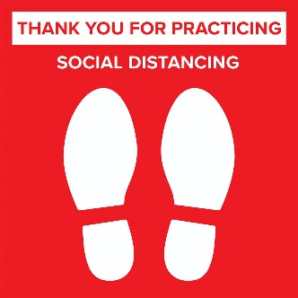
Social Distancing Throughout the Day
Students will be given verbal and visual reminders to remain socially distanced through the day as much as it is feasible for our school. Different areas of the school pose different situations. Teachers and staff will remain vigilant about reminding students to social distance.

Some situations St. Peter’s has identified for Social Distancing are:
- Hallway—Stickers placed on wall to mark 3 or 6 feet for lining up in the hallway. All will be asked to face the same direction when in line in the hallways.
- Classrooms—Desks have been moved as far apart as possible allowing for students to be 4-6 feet apart depending on classroom size. All desks are facing the same direction. Dots are also placed on some classroom floors to remind students of social distancing and give them a place to stand or sit.
- Music—Students will focus on fundamentals of music such as notes and rhythm to begin the year. Classes may also take place outside or in the church while social distancing so singing can occur. Schedules have been adjusted to allow for sanitation in the music room between classes.
- Plexiglass—The office and all classrooms have plexiglass for office personnel to converse with students and visitors and for teachers to be behind when giving direct instruction. The lunchroom serving area also has plexiglass to create a barrier between the cook and students. Paras will serve lunch and not 5th/6th grade students.
- Morning Recess—The students will be divided into two groups for recess to have less students on the playground. Students will also be encouraged to play in their designated areas with students from their own class. There will be two sets of playground equipment that will be sanitized after each recess. Students will sanitize and/or wash hands before and after each recess.
- Lunch Recess—The students will be divided into their same two groups for lunch and for lunch recess. We will have two lunch periods and two recess times.
- Mass—Students will sit with minimum of 3 feet apart.
- Breakfast/Lunch—Students will stagger at tables to eat. An extra lunch period has been added to accommodate social distancing.
- Marathon—Families will be encouraged to do phone calls to obtain pledges. There will also be emails sent out to parents to use to connect with people for online giving.
*All other situations will be guided by teachers and staff to ensure safety measures are being followed.

Transportation
Students may continue to use the bus provided by the public school based on conversation and protocols set forth by the public school. Should the public school change to distance learning and St. Peter’s School is still in-person learning, it will become the responsibility of the parent to arrange transportation. Drop-off and pick-up times may be adjusted to accommodate earlier/later times if needed if there is no bus provided from the public school. Any arrangements with the Prairie 5 white bus should be made by parents.
Guidance on returning to school/work for individuals with symptoms or diagnosis.
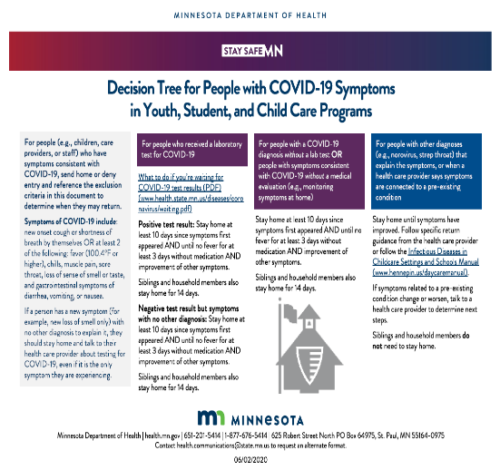
Students or staff who become ill with COVID symptoms during the school day will be assessed and provided a safe place to isolate until child/staff can leave the school building. Those with symptoms should self-isolate for 10 days after symptoms first appeared. Those who have been diagnosed should complete a 14-day quarantine and be fever free (below 100.4º F) without medication for three days before returning to school. A doctor’s note is not required to return to school, but we ask that you make sure you have followed all return to school protocols. Teachers who may need to quarantine or isolate because of close contact and who are not ill will continue to teach via Zoom with a para or classroom monitor supervising the students. MDE and Countryside Public Health will guide protocols for all confirmed cases of COVID in the school.

Distant Learning Plan
If the school should have to resort to Distance Learning (DL) schoolwide or for once specific classroom, parents will be notified immediately. Distance Learning will take place with the use of live Zoom lessons (recorded if not able to attend), SeeSaw (or Zoom) lessons (grades PreK-2), Google Classroom postings (3rd—6th), and parent support with packet pick-up and drop-off. Teachers will take into consideration standards that need to be met and focus on such lessons during Distance Learning. Workload will not exceed daily in-school requirements. Teachers will provide a daily or weekly schedule of assignments due by end of week. Specials such as Music, Social, Science, and PE will alternate a week of lessons to be taught as to not have more than one special per week. Parent Zoom meeting will be scheduled for support to parents to discuss any questions, needs, or to provide resources for parents and students during DL. We encourage families to remain on the Lunch Program if it can be provided like it was in the spring. That daily connection, little as it may seem, helps families and students stay connected to the school.
If a family would choose to do Distance Learning for the school year, it would be an entire year commitment and would be instructed using Seton Home School Study resources. Lessons would not be live or recorded for students and all materials would be provided through Seton. Classroom teachers would connect weekly with student to check in and would have access to see student progress online. Full tuition would still be required, and St. Peter’s would pay Seton.

Health and Well-Being Action Plans

Disinfecting / Cleaning
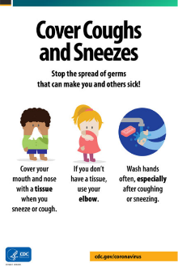
Classrooms, restrooms, and commonly used spaces will be disinfected daily. High-touch areas will be disinfected frequently throughout the day by the custodian, teachers, and paras. Preschool/Kindergarten toys and recess equipment will be disinfected daily by paras. Lunchroom tables will be cleaned between lunch periods and disinfected after lunch and breakfast. Signs will be posted around school to remind students of proper handwashing, covering cough and sneeze, face covering, etc. Teachers will remind students to use sanitizer or wash hands frequently.

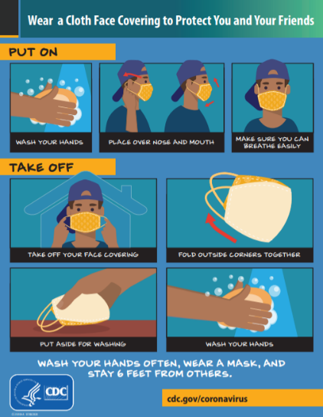
Cloth Face Coverings
Due to the Executive Order 20-81 issued by Governor Walz, all students and staff are required to have a face covering while in the school building (no face shields for students at this time). To keep consistent while in a combination classroom, preschoolers are also required to have a face covering at school. Preschoolers use of face covering will vary on classroom setting of whole class with kindergarten (required) or in smaller reading groups or groupings (not required).
Students will be required to wear a face covering when in the classroom, hallway, restroom, at Mass, and at the breakfast/lunch table when not eating. Students are not required to wear a face covering while eating or drinking, at recess, during PE, when outside while social distancing, or when proper social distancing of 6 feet can occur for short amounts of time.
Students will be given optional “mask breaks” during the day either in the classroom or outside as the teacher sees it can be safely done. Mask breaks will be short chances for the student to remove their mask if they choose and can do so safely following the teacher’s instructions. Some examples might be if students are doing silent reading while social distancing or go outside for a class or a break. Students and staff are permitted to continue to wear appropriate face coverings at any time during the school day even if not required as listed above. Parents should discuss their desires for face covering with children at home regarding desire to wear all day or allowed to take the mask breaks when given. However, teachers are not responsible if a child removes their face covering during a permitted time but was not the desire of the parent.
Face coverings should be brought home daily and washed. Face coverings include paper or disposable face mask, a cloth face mask, a scarf, a bandanna, or a neck gaiter. Face coverings should be respectful of our Catholic environment, and must not contain any obscene, inappropriate, political, or otherwise distracting/offensive content on them. Face shields are not permitted in place of a mask for students. Teachers will be allowed to remove mask when giving direct instruction behind the plexiglass or when using a face shield to work with students in each classroom but will put their mask back on when done with direct instruction or student help.
A mask will be provided for all students and staff. A face covering may also be brought from home. Please label your child’s mask with initials or name. Disposable masks are available in the school office should someone require or request a mask. Please wash cloth face coverings daily. Students will be given a paper bag to store their face coverings during lunch, recess, PE, etc.
Should a student or staff member need special accommodations involving a face covering, a phone call or email to the principal should be made to explain the situation and to discuss options. All medical accommodations must be accompanied with a doctor’s note from a certified medical professional. If needed, the principal will consult with the Task Force on recommendations and an alternative plan.

Drinking Fountain
Students are encouraged to bring a water bottle from home filled with water (no juice, milk, sodas, or other beverage). Students may refill water bottle with the water fountain using the water bottle feature. Water bottles should be brought home each day and cleaned thoroughly before using again. Water bottles should also be labeled with child’s name clearly visible.

Ventilation
All rooms have the air conditioning unit install that creates air flow in the classroom. Teachers and staff will be encouraged to open windows when possible and to leave classroom doors open while teaching. Consideration will be made for window fans to push air out of rooms if needed. Other fans for each classroom, work area, or hallway are available if needed to create more ventilation as well.

Curriculum & Instruction

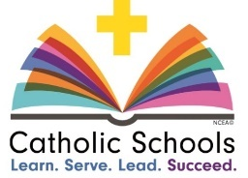
Standards / Assessment
Classroom teachers will prepare lessons that focus mainly on the Curriculum Standards we have at St. Peter’s School while knowing that all the “extra” activities may not be able to be included this year. Teachers will continue to uphold our high standards of academics but also be considerate of the learning gaps that may have occurred. Daily monitoring of student work along with assessments from textbooks, online (AR), and other evaluation of student work will help teachers identify learning gaps and provide a plan to move forward. Students will also take the NWEA test early in October to identify major learning gaps that will need to be addressed throughout the year. Preschool and Kindergarten assessment will begin right away as normal procedure.

Report Cards
Reports cards will be focused on the academic progress of each student. The behavior portion of the report card will be marked being more sensitive to the surrounding factors. There will not be an attendance award this school year.
In the event that St. Peter’s School would need to transition to Distance Learning schoolwide, specials (Social, Science, Music, Art, PE) will all change to the Degree of S grading scale during any needed Distance Learning. All other grading will remain the same knowing there is some leeway in regard to regular coursework without giving up the integrity of the curriculum standards.

Distance Learning Plan
If St. Peter’s School must move to a Distance Learning model for a temporary or long-term school closure, parents will be notified immediately. Students in grades Preschool—2nd grade will be provided with an iPad while students in grades 3-6 will be provided with a Chromebook to have consistent platforms at home. Teachers will prepare lessons keeping the curriculum standards at the core of all lessons. Lessons will be provided using a combination of live Zoom meetings (staggered times with teachers for home internet concerns and recorded if students are not able to join at assigned time), recorded and posted lessons, student packets, and/or assigned self-paced lessons. Specials (Music, Social, Science, and PE) will be on a weekly rotation with short lessons to be completed by end of the week. Weekly folder pick-up and drop-offs will be on Mondays or the first day of the week. Weekly Zoom meetings for students and teachers to check in with each other will occur as well as weekly Zoom meetings for parents to touch base or provide resources for them will also be held. A comprehensive plan will be communicated if DL is needed.
Resource | Access / Use
‘Leading with Hope’ from the Andrew Greeley Center for Catholic Education | https://www.luc.edu/gcce/index.shtml  - Logistics and planning guidance  - Maintaining community guidance  - Curriculum and instruction guidance  - Promoting Catholic identity guidance  - Technology support guidance
‘Guide to Reopening’ from Catholic Mutual Group | http://catholicmutual.org/en-us/home/covid-19caresresources.aspx  - Staying home guidance  - Health screening  - Social distancing directives  - Facility cleanliness and disinfecting considerations  - Facility operational considerations  - Transportation recommendations
Minnesota Department of Health | https://www.health.state.mn.us/diseases/coronavirus/schools/  - Decision Tree for People with COVID-19 Symptoms  - Public School Planning Guide  - Masking Recommendations  - Food Service Information  - Cleaning and Disinfecting Guidance
Center for Disease Control | https://www.cdc.gov/coronavirus/2019-ncov/community/index.html  - Signage for posting  - Screening checklist  - Best practices in hand and respiratory etiquette  - Cleaning and disinfecting guidance  - Working with higher risk individuals  - Congregated setting recommendations  - Preparations for outbreak or diagnosis in facility
Additional Planning Resources
American Academy of Pediatrics | https://services.aap.org/en/pages/2019-novel-coronavirus-covid-19- infections/clinical-guidance/covid-19-planning-considerations-return-to-in- person-education-in-schools/  - Recommendations for age categories  - Recommendations for cleaning and disinfecting  - Use of masks and PPE  - Guidance on mental health of students and staff
COVID-19 Preparedness Guidance : A Path for Students’ Return to School Fall 2020 | Diocese of Crookston, Duluth, New Ulm, St. Cloud, Winona-Rochester  - Planning Guide for schools

Resources

Updated: Aug. 20, 2020

